

|  |  |
| --- | --- |
| Data Visualization | |
|  |  |
| JustIT Bootcamp27 March 2023Adewunmi Adeleye |  |

|  |  |  |
| --- | --- | --- |
| Contents  • Cover page ..............................................................................................................................1  • Table of Contents....................................................................................................................2  • Main body ...............................................................................................................................3  • A reflective...............................................................................................................................3  Assignment 1 Data Structure and Policies .............................................................................3  Scenario........................................................................................................................................3  Policies and Procedures.............................................................................................................4  Excel..............................................................................................................................................4  The data........................................................................................................................................5  Tableau ........................................................................................................................................7    **Data Structure and Policies** |  |  |
|  | | |
|  |  | |
|  |
|  |  | |

When working with data, it is important to adhere to certain policies to ensure that the data is handled ethically, securely, and in compliance with legal regulations. Here are some key policies that should be followed:

* Data Privacy Policy: This policy defines how personal data is collected, processed, stored, and used by an organization. It outlines the measures taken to ensure the privacy and security of the data, as well as the rights of the individuals whose data is being collected.
* Data Security Policy: This policy outlines the measures taken to protect data from unauthorized access, theft, or loss. It includes guidelines for the use of passwords, encryption, firewalls, and other security measures.
* Data Retention Policy: This policy defines how long data is kept and when it should be deleted. It outlines the legal requirements for data retention, as well as the organization's own policies for retaining data.
* Data Sharing Policy: This policy outlines the rules for sharing data with third parties. It specifies the types of data that can be shared, the purposes for which it can be shared, and the conditions under which it can be shared.
* Data Governance Policy: This policy defines the roles and responsibilities of employees and departments regarding data management. It outlines the procedures for data collection, processing, and storage, as well as the measures taken to ensure data quality and accuracy.
* Data Access Policy: This policy defines who has access to data and under what conditions. It includes guidelines for granting and revoking access, as well as rules for monitoring data access and usage.
* Data Ethics Policy: This policy outlines the ethical principles that guide the collection, processing, and use of data. It includes guidelines for ensuring fairness, transparency, and accountability in all data-related activities.

Adhering to these policies will help organizations to handle data ethically and securely, and to comply with legal regulations.

As a data analyst, it is important to be aware of rules and regulations that govern data management and analysis for several reasons:

* Compliance: Compliance with laws and regulations is critical for any organization. As a data analyst, you may be working with sensitive data that needs to be handled in accordance with specific rules and regulations, such as data privacy laws (e.g., GDPR, CCPA). Failing to comply with these laws can result in legal consequences and damage to the reputation of the organization.
* Accuracy: Following rules and guidelines for data analysis ensures that the data you are working with is accurate and reliable. This, in turn, leads to better decision-making and more effective strategies for the organization.
* Ethics: Data analysts have a responsibility to ensure that their work is ethical and does not harm any individuals or groups. Following rules and guidelines helps to ensure that you are conducting your work in an ethical manner.
* Consistency: Following rules and guidelines helps to ensure that data analysis is consistent across the organization. This is important for comparing data over time and across different projects.

Overall, being aware of the rules and regulations that govern data management and analysis is essential for any data analyst. It helps to ensure compliance, accuracy, ethics, and consistency in their work.

**Policies and Procedures**

We will be working with ‘The Wealth of nations’ data, resources from https://justit831.sharepoint.com/:x:/s/DataAnalyticsProgrammeNewStandards/EVK1dsCfWvZMpvJzG9QaQk8B1nxx7hYR0KtGfbzJauf94g?e=CR1LFE

We set a password to protect the workbook to obey the rules and regulations of data governance and management.

We highlighted the column C (with Dollar symbol) and change the data to display in British Pound symbol.

The GDP dataset sheet was turned into a table and filtered the table to display the information for year 2019 only.

Created a chart for the rank, country and GDP. Also, labelled the chart, inserted the X and Y axes.

We moved the chart to another sheet titled GDP Chart.

Then selected the first 20 highest ranking countries GDP in year 2019.

Tableau

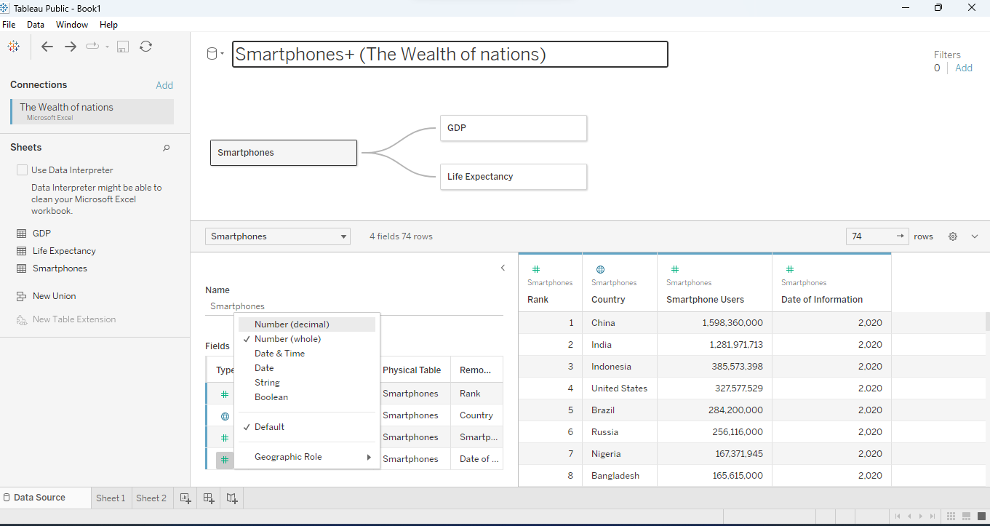

Yearly GDP per capita for each countries was displayed.

Selecting the highest country ranking and filtering.

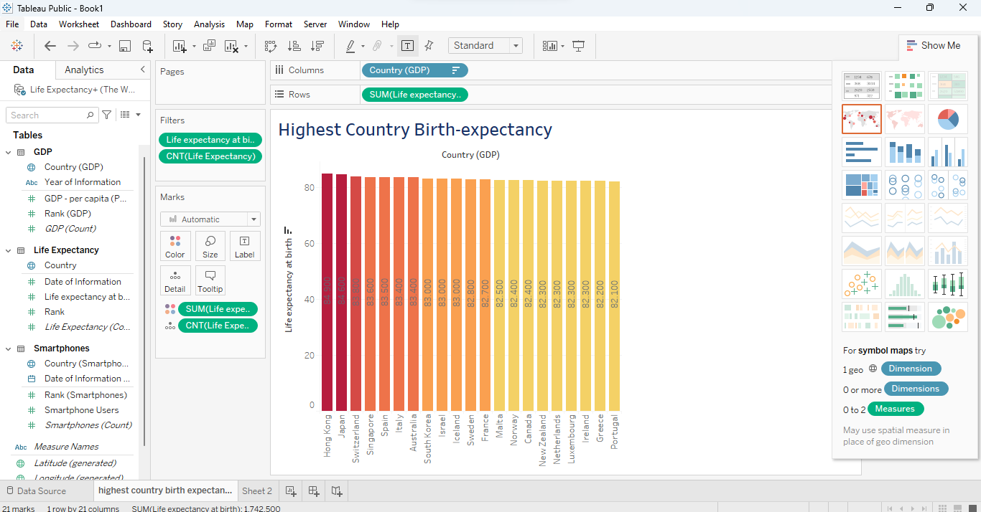

Using geographical (map) visualization to rank the highest country smartphone users with year.

Also, use the highest countries ranking for best smartphone users.

Top of Form

|  |  |  |  |  |
| --- | --- | --- | --- | --- |
|  | | | | |
|  |  |  |  |  |

|  |  |  |
| --- | --- | --- |
|  |  |  |
|  |  |  |
|  |  |  |